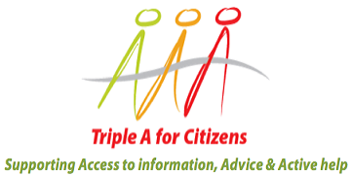

Brussels, 18 September 2015

Dear Sir/Madam,

We, the implementing partners of the project Triple A for citizens, Access to information, advice and Active help, and members of the Triple A network, are deeply concerned by the lack of a common European approach to the current migrant crisis in Europe and by the threat this poses to such founding principles of the Union as solidarity, freedom of movement and protection of human rights. For that reason we have decided to join the U-Impact ACCES campaign for a higher involvement of citizens in the discussions concerning this issue.

As representatives of organizations working on providing free legal aid and counsel to refugees and asylum seekers traveling through our countries in Western Balkans and Turkey, but also in the destination countries of the European Union, we are especially concerned by what we believe is an inadequate involvement of the EU institutions with organisations working directly with refugees on issues such as creating a common migration policy and reviewing the mechanisms which guarantee freedom of movement.

The undersigned organisations include the European Citizen Action Service (ECAS) in Belgium, National Association of Citizens Information Services in Ireland, the National Association of Citizens Advice Bureaux in Romania, Law Centres Network in the UK, Association for Democratic Initiatives in Bosnia and Herzegovina, Civil Rights Program in Kosovo, Lawyers' Committee for Human Rights in Serbia, Civil Society Development Centre in Turkey, Macedonian Young Lawyers Association, Open Society Foundation Albania, Centre for Monitoring and Research in Montenegro, Vasa Prava BiH Legal Aid network, the Foundation for Local Democracy in BiH, Civil Rights Project Sisak, Zajedno Zajedno Serbia, and the Network of the Committees for Human
Rights Serbia.
Our organizations are committed to participating with our expertise in the development of such policies and urge you to stand for citizen participation in the decision-making process on these important issues.

Sincerely,

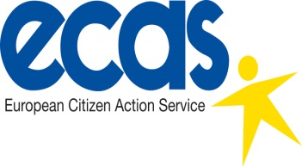 | 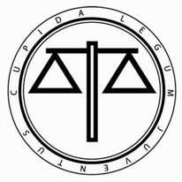 | 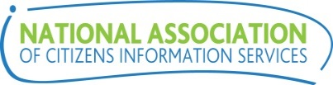
European Citizen Action Service | Macedonian Young Lawyers Association | National Association of Citizens Information Services
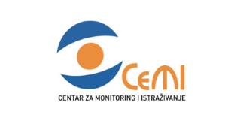 | 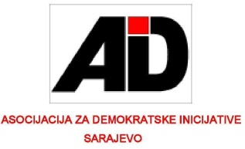 | 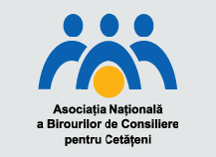
Centre for Monitoring and Research | Association for Democratic Initatives | National Association of Citizens Advice Bureaux Romania
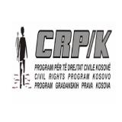 | 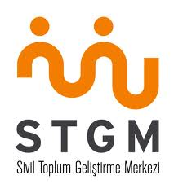
Civil Rights Project Kosovo | Civil Society Development Centre | Lawyers' Committee for Human Rights in Serbia
Open Society Foundation Albania | Law Centres Network | Foundation for Local Democracy
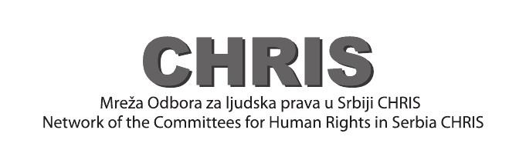 |  | 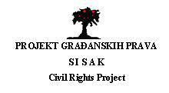
Network of the Committees for Human Rights in Serbia | Vasa Prava BiH | Civil Rights Project Sisak
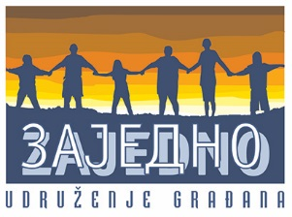
Zajedno Zajedno

